**Lab 2 – Amazon EMR and University Hadoop System**

**1. Run the max-temperature jar from your terminal or putty by remotely connecting to Amazon EMR, and paste the output file directory and the output file content:**

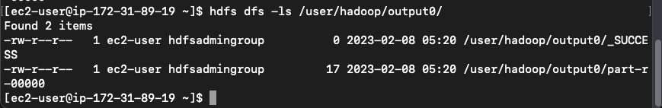

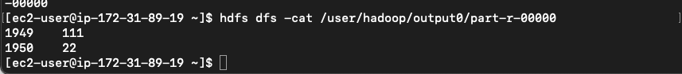

**2. Run the commands in Amazon EMR for Example 3-1 and paste the outputs in the following :**

(1). javac -cp src/:hadoop-common-2.6.1.jar:hadoop-mapreduce-client-core-2.6.1.jar:commons-cli-2.0.jar -d . URLCat.java

(2). hadoop URLCat hdfs:///user/hadoop/quangle.txt

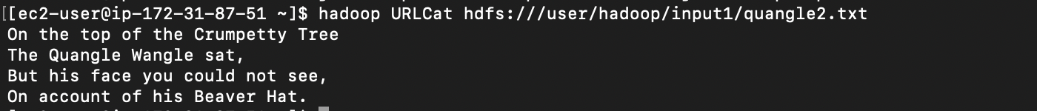

**3. Run the commands in Amazon EMR for Example 3-2 and paste the outputs in the following :**

(1). javac -cp src/:hadoop-common-2.6.1.jar:hadoop-mapreduce-client-core-2.6.1.jar:commons-cli-2.0.jar -d . FileSystemCat.java

(2). hadoop FileSystemCat hdfs:///user/hadoop/quangle.txt

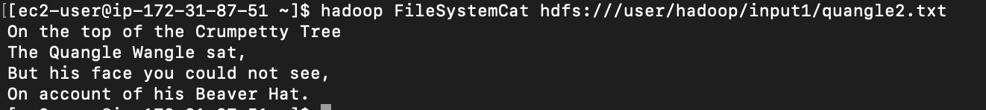

**4. Run the commands in Amazon EMR for checksum of two files and paste the outputs in the following:**

(1). hdfs dfs -copyToLocal /user/hadoop/quangle.txt quangle.copy.tx

md5sum quangle.txt quangle.copy.txt

